**Experiment No.: 3 Date -06-03-2023**

**Aim**

Familiarisation of Linux Commands

**CO2**

Perform System Aministration tasks

**Procedure**

$pwd



$ls



$ls -R

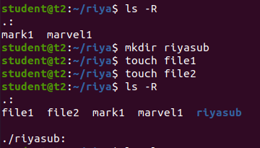

$ls -l

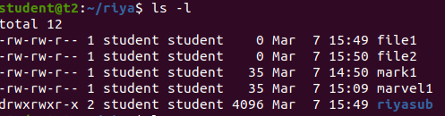

$ls -a



$ls -al

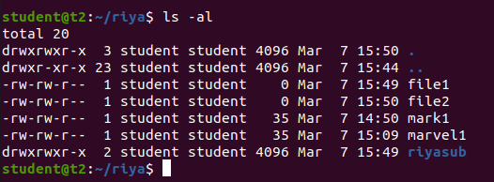

$ls -t



$ls -r



$history

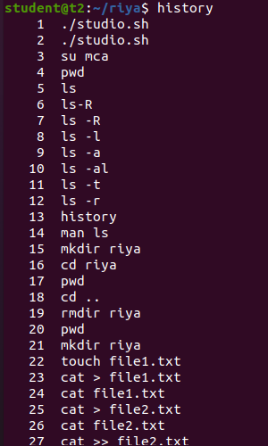

**$ man ls**

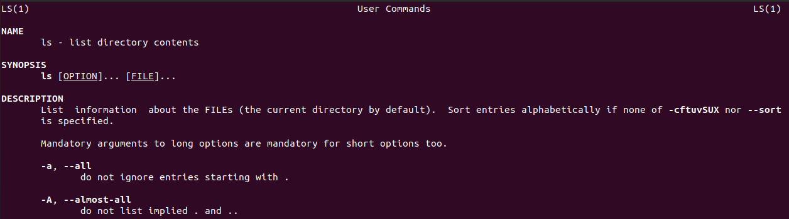

**$mkdir directoryname**



**$ cd ..**



**$ rmdir**

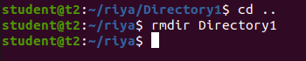

**$touch filename**



**$cat > file1.txt**

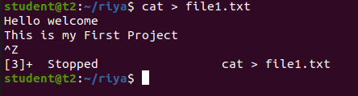

**$cat >> file1.txt**

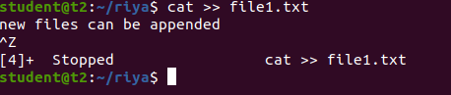

**$cat file1.txt file2.txt > file3.txt**

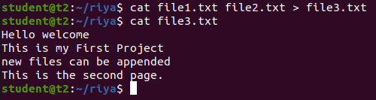

**$cat -n file3.txt**

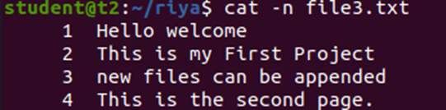

**$cat -b file4.txt**

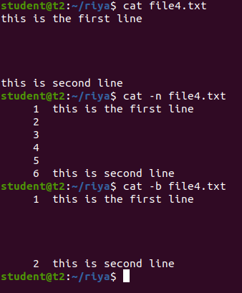

**$cat -e file2.txt**



**$cat c.txt | tr a-z A-Z > output.txt**

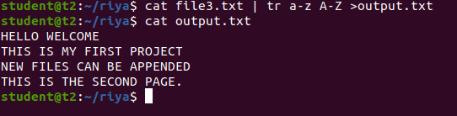

**Result**

The program was executed and the result was successfully obtained. Thus CO2 was obtained.

**Experiment No.: 4 Date -07-03-2023**

**Aim**

Familiarisation of Linux Commands

**CO2**

Perform System Aministration tasks

**Procedure**

$cut -b1 filename

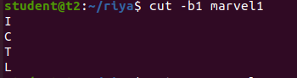

$cut -c3 filename

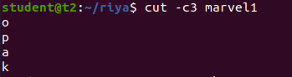

$cut -d ‘ ‘ -f1 filename

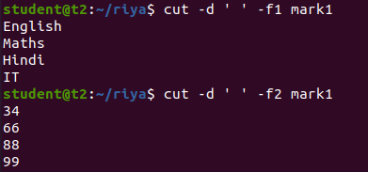

$paste mark1 mark2

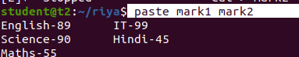

$paste -d ‘-’ mark1 mark2 > mark3

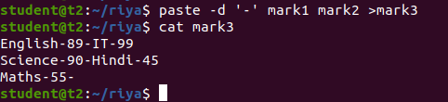

$paste -s mark1



$cp mark1 mark2

(content in mark1 is overwritten in mark2)

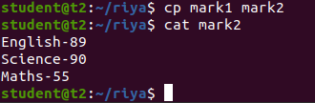

$cp -r riya riya2

(to copy the directory along with its sub directories)

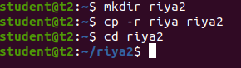

$cp filename directoryname

(to copy file from one directory to another directory)

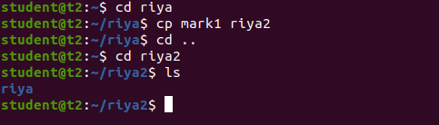

**Result**

The program was executed and the result was successfully obtained. Thus CO2 was obtained.

**Experiment No.: 5 Date -13-03-2023**

**Aim**

Familiarisation of Linux Commands

**CO2**

Perform System Aministration tasks

**Procedure**

$read and echo

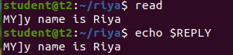

$read var1 var2 var3

(raeding the contents to 3 diffrent variables var1 var2 var3)

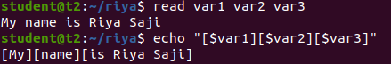

$read (the contents for multiple lines with \ at the end of each line)

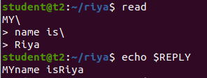

$read -p

(for prompt text from user)

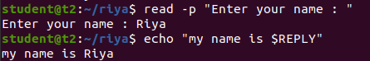

$read - n6

(specifying the limit for the content to read)





$read -s

(security)

and $echo $REPLY (to display the password)



$wc filename



$wc -l filename



$wc -m filename



$wc -c filename



$wc -w filename



$wc -L filename



$more content.txt

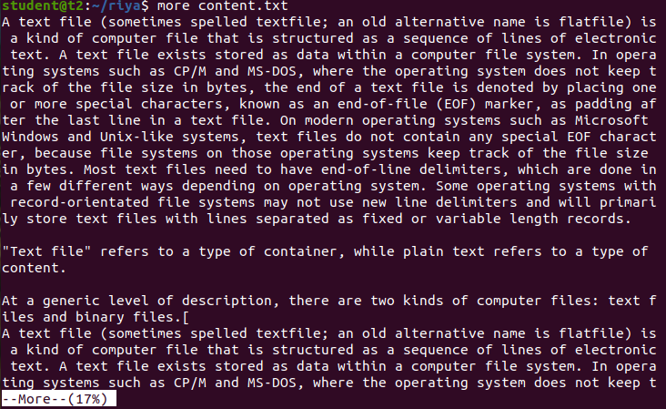

$more +20 content.txt

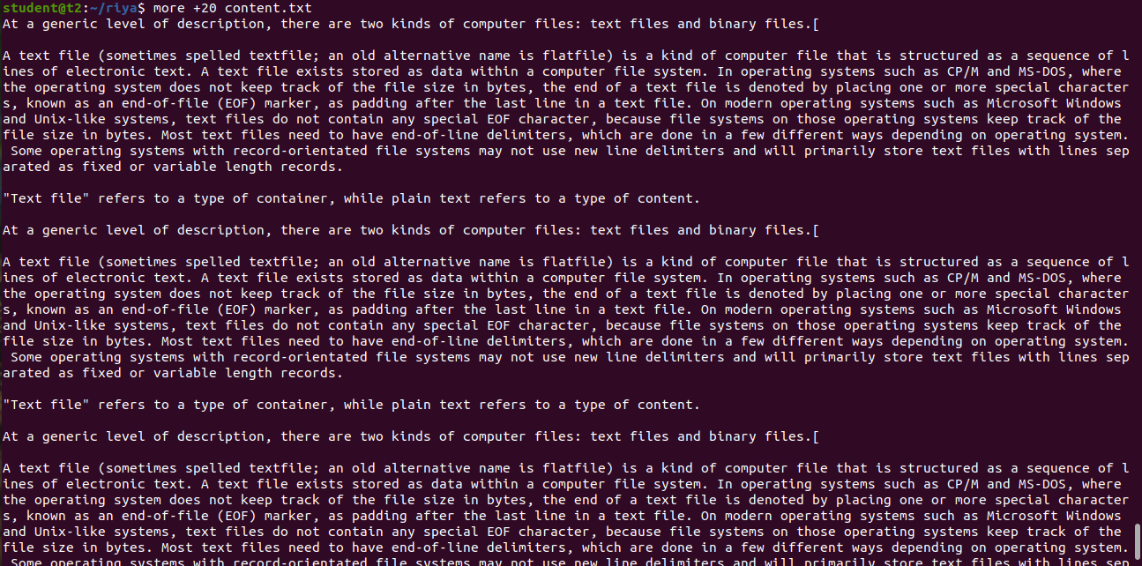

$more +/pattern filename

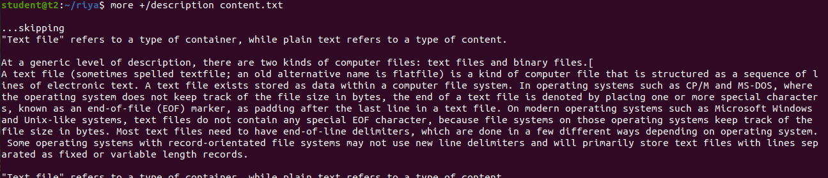

$more -d filename

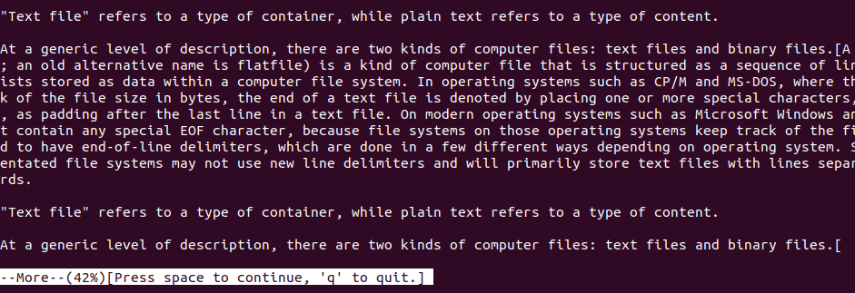

**Result**

The program was executed and the result was successfully obtained. Thus CO2 was obtained.

**Experiment No.: 6 Date -14-03-2023**

**Aim**

Familiarisation of Linux Commands

**CO2**

Perform System Aministration tasks

**Procedure**

$grep -i searchword filename

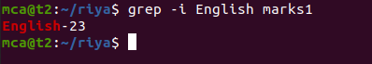

$grep -v searchword filename

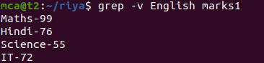

$grep -A1 searchword filename



$grep -B1 searchword filename



$grep -C1 searchword filename

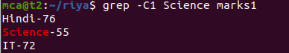

$head filename

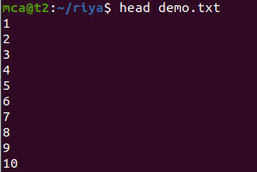

$head -5 filename

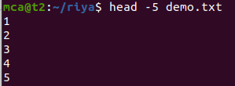

$tail filename

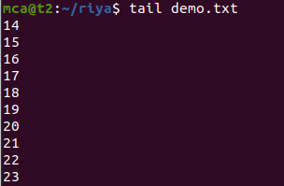

$tail -5 filename

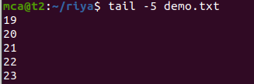

$mv filename filename2

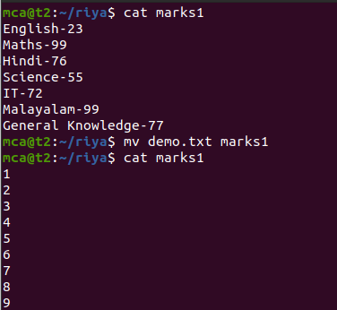

$mv -b filename filename2

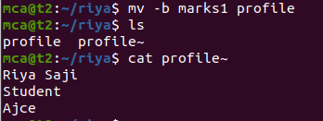

$mv -i filename filename2

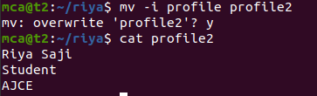

**Result**

The program was executed and the result was successfully obtained. Thus CO2 was obtained.